Home Repair Website

# Background

As everyone knows, most houses in Australia are made of wood, which can be easily damaged if not properly protected. If a house is damaged by an accident, such as a storm or heavy rain, the homeowner needs to find a skilled electrician or carpenter to carry out the repairs. However, finding the right person for the job can be challenging, as most electricians and carpenters are often very busy. Typically, the homeowner needs to contact several engineers and schedule a time for them to visit the site. Only then can they assess the damage and provide a cost estimate for the repairs.

While homeowners can delegate this task to service providers like HomeRepair (https://www.homerepair.com.au/), this often comes with a higher fee.

To address this, I want to design a C to C website where homeowners can easily connect with electricians and carpenters, and where tradespeople can more easily find customers.

# A Sit Map

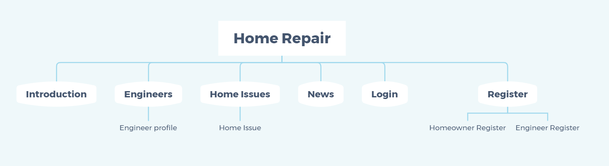

The objective of this website is to assist homeowners in promptly addressing and resolving house-related issues. The platform is organized into six primary modules: Introduction, Engineers, Home Issue, News, Login, and Register.

# Wireframe

## Introduction

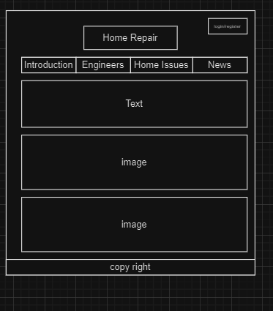

## Engineers

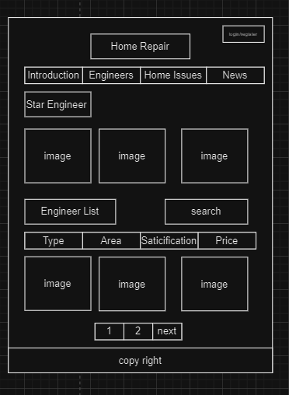

## Home Issues

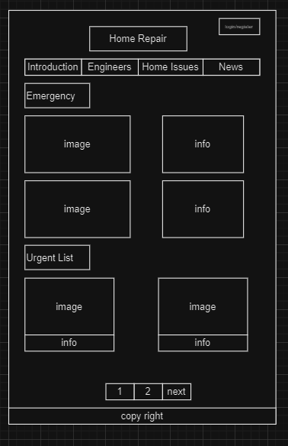

## News

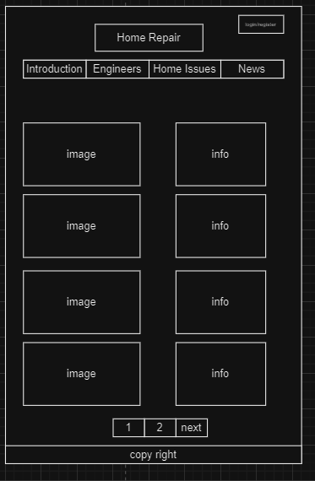

## Login

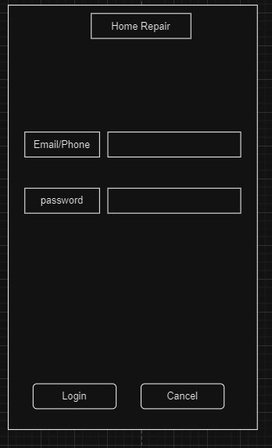

## Register

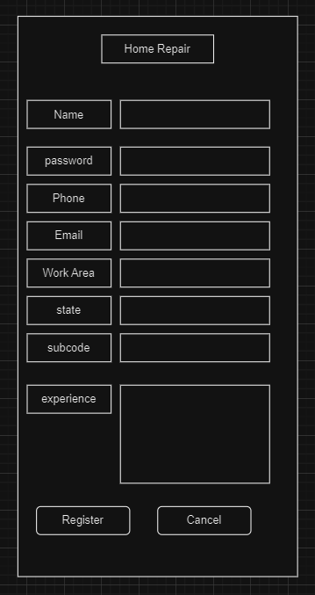

# UI

## Introduction

Introducing the vision of this website, along with a successful case.

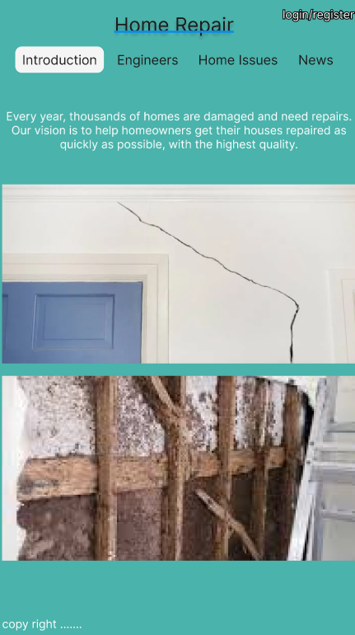

## Engineers

Provide a list of the most popular engineers and display all engineers using a paginated format.

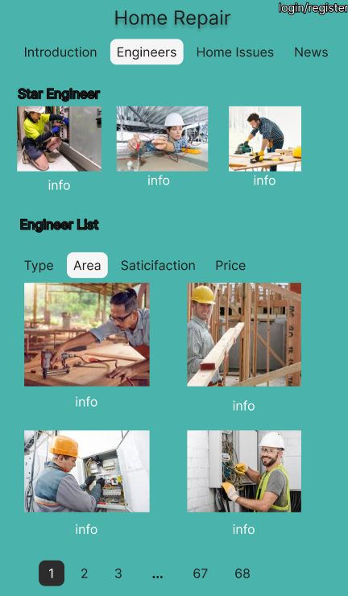

## Home Issue

Display urgent home issues and provide a comprehensive list of all home issues, allowing available engineers to contact the homeowners directly.

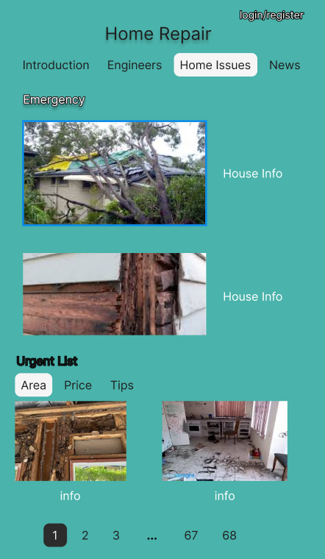

## News

Provide a series of news articles on topics such as weather updates and other relevant information, aimed at helping homeowners protect and maintain their properties.

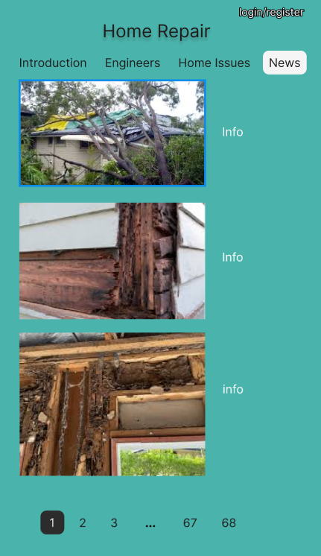

## Login

Homeowners login or engineers login

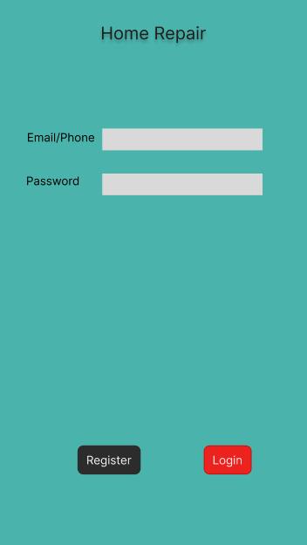

## Register

Homeowner register

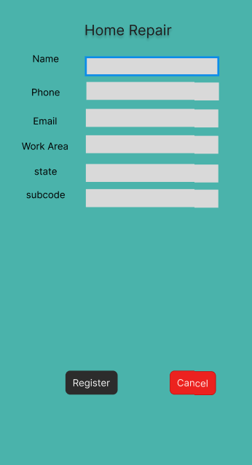

Engineer Register

